For Private Circulation Only |  |  | R. No. 29/14/AL/89-TC Gen. 04/XXV/X (110)
 | Dewas udyog circle
Issue No – 442 |  | Monthly Newsletter |  | March, 2026
President  Mr. Ashok Khandelia  Hon. Secretary  Mr. Anjan Shah |  | B.R. Ambedkar Remembrance Day  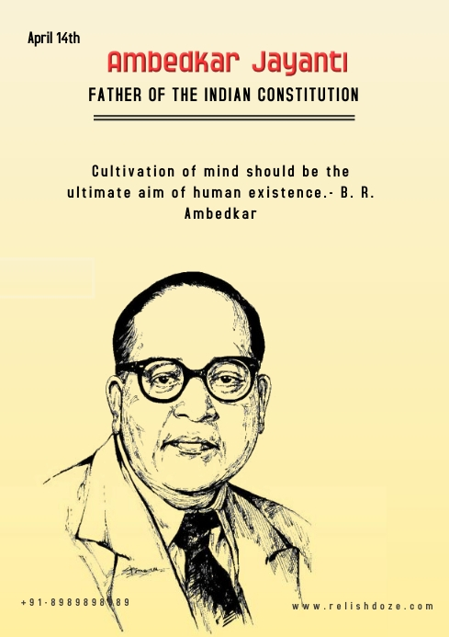
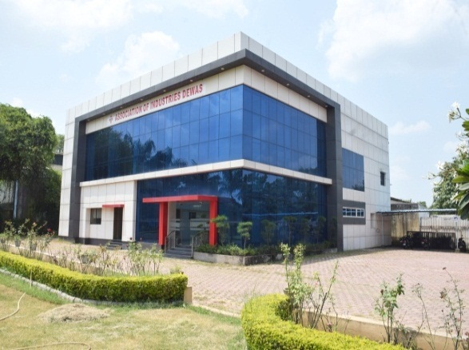
Inside pages…………….  Knowledge Centre  Notifications/Circulars  Events  Attainments  Member’s Corner  Sponsor’s Page |  | National Civil Service Day  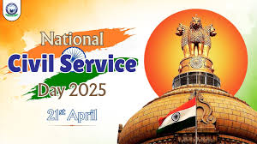
ASSOCIATION OF INDUSTRIES DEWAS

1/B, 1/B/2A, I. S. Gajra Industrial Area No. 1, A. B. Road, DEWAS (M.P.) Phone: (07272) 258052–53, 259455
E-mail : aidewas123@gmail.com Website : www.aidewas.org

DEWAS UDYOG CIRCLE | 02 | March, 2026
knowledge centre
B.R. Ambedkar Remembrance Day

Ambedkar Jayanti, also known as Bhim Jayanti, is observed on 14 April to commemorate the memory of B. R. Ambedkar, Indian politician and social reformer. It marks Ambedkar's birthday who was born on 14 April 1891. His birthday is also referred to as Equality Day by some in India.
Ambedkar Jayanti processions are carried out by his followers at Chaitya Bhoomi in Mumbai and Deeksha Bhoomi in Nagpur. It is a customary for senior national figures, such as the President, Prime Minister and leaders of major political parties, to pay homage at the statue of Ambedkar at the Parliament of India in New Delhi.

National Civil Service Day

In India, the Civil Service is the collection of civil servants of the government who constitute the permanent executive branch of the country. This includes career officials in the All India Services, the Central Civil Services, and various State Civil Services. The civil service forms the basis of the Government, without which there is no administration. They act as the main channel to articulate people's needs and implement government policies on the ground.

Important Days in April
April 1 | Orissa Day
April 5 | National Maritime Day
April 7 | World Health Day
April 11 | National Safe Motherhood Day
April 13 | Jallian wallah Bagh Massacre Day (1919)
April 14 | B. R. Ambedkar Remembrance Day
April 17 | World Hemophilia Day
April 18 | World Heritage Day
April 21 | National Civil Service Day
April 22 | World Earth Day
April 23 | World Books Day
April 24 | Panchayat Raj Day
April 26 | World Intellectual Property Day

“We cannot solve problems with the kind of thinking we employed when we came up with them.” —Albert Einstein

cannot solve problems with the kind of thinking we employed when we came up with them.” — Albert Einstein

DEWAS UDYOG CIRCLE |  | 03 |  | March, 2026
NOTIFICATIONS/circulars
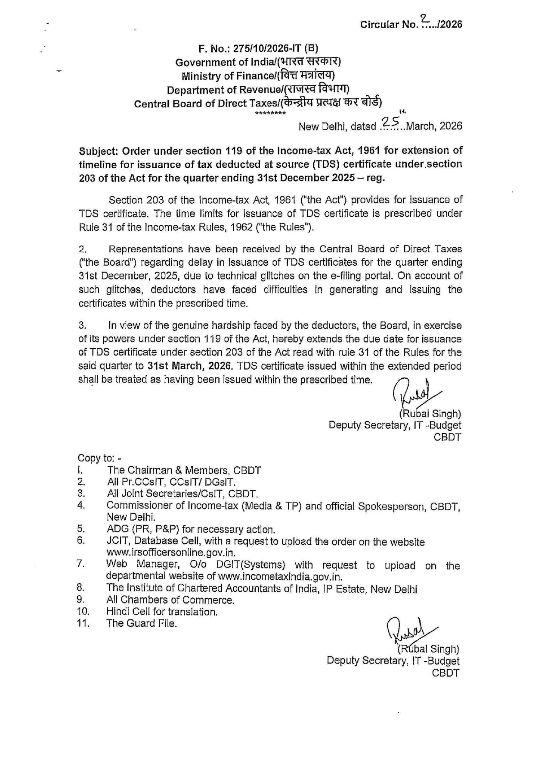

“Develop success from failures. Discouragement and failure are two of the surest stepping stones to success.” —Dale Carnegie
DEWAS UDYOG CIRCLE | 04 |  | March, 2026
NOTIFICATIONS/circulars
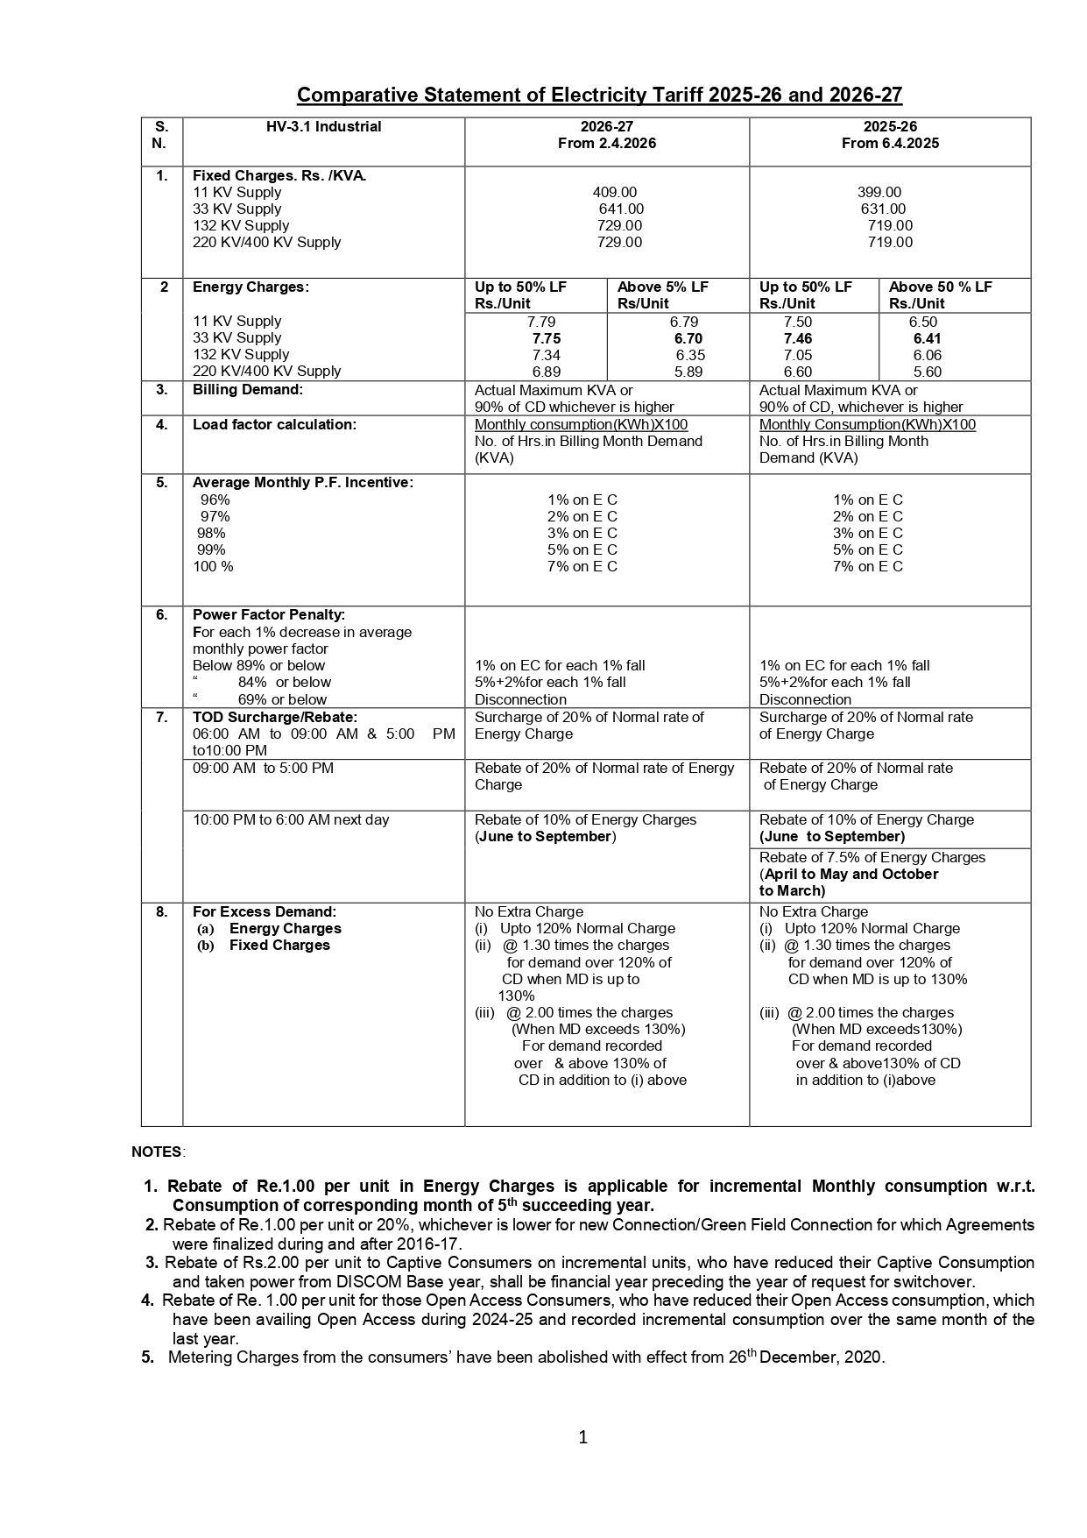

“There’s nothing like a really loyal, dependable, good friend. Nothing.” – Jennifer Aniston
DEWAS UDYOG CIRCLE | 05 | March, 2026
NOTIFICATIONS/circulars
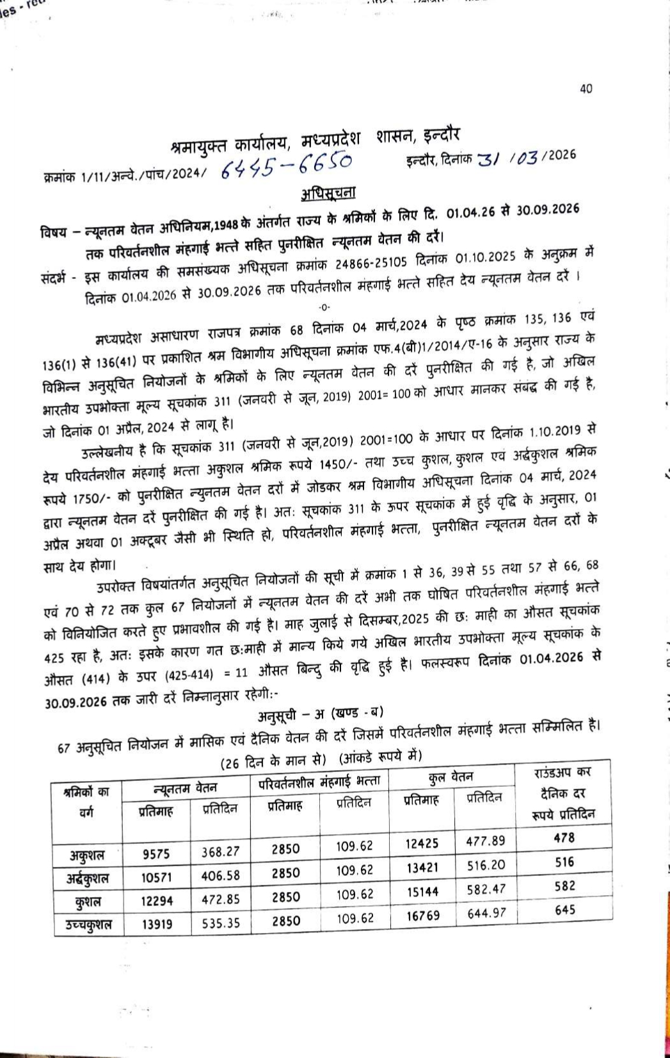
Cont’d to next page

“Setting goals is the first step in turning the invisible into the visible.” —Tony Robbins

DEWAS UDYOG CIRCLE | 06 | March, 2026
NOTIFICATIONS/circulars
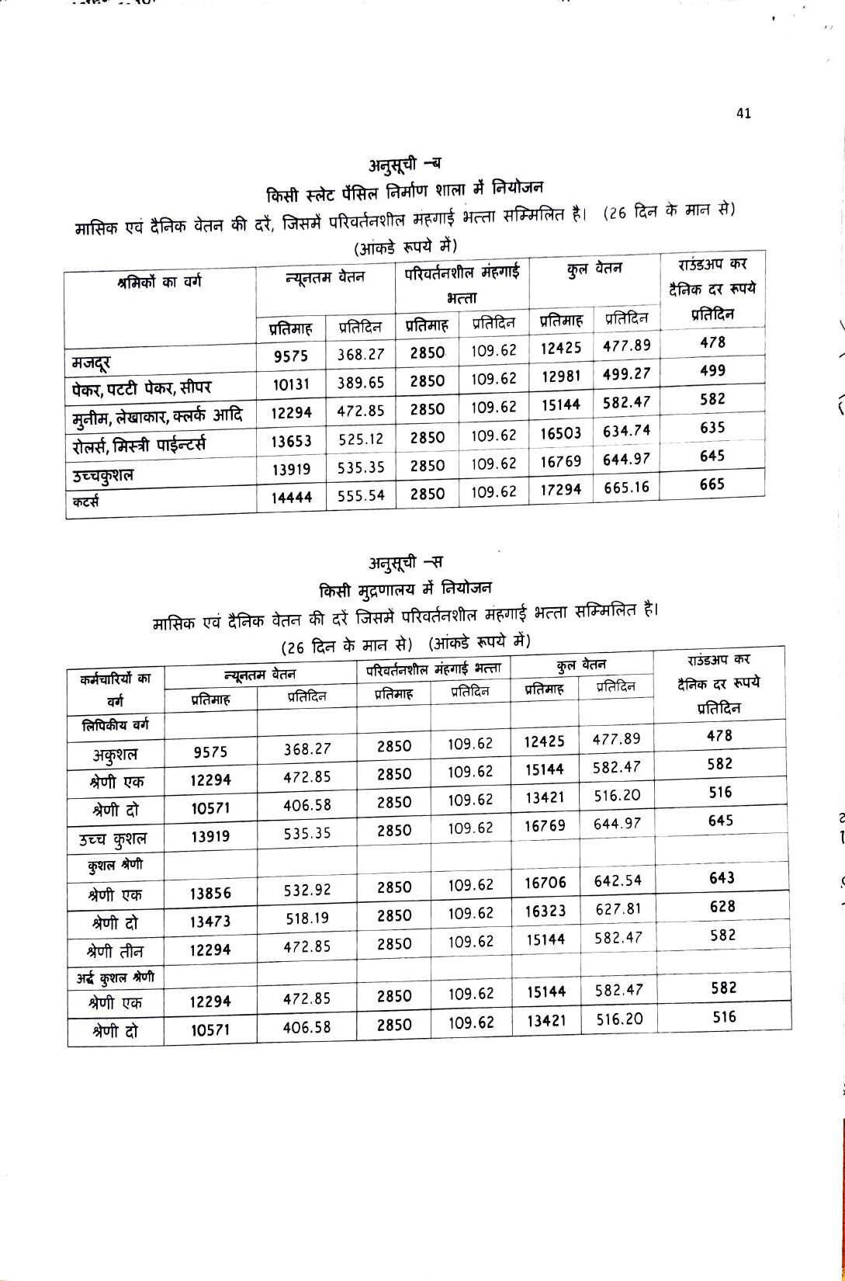
Cont’d to next page

“The only way to have a friend is to be one.” – Ralph Waldo Emerson

DEWAS UDYOG CIRCLE | 07 | March, 2026
NOTIFICATIONS/circulars

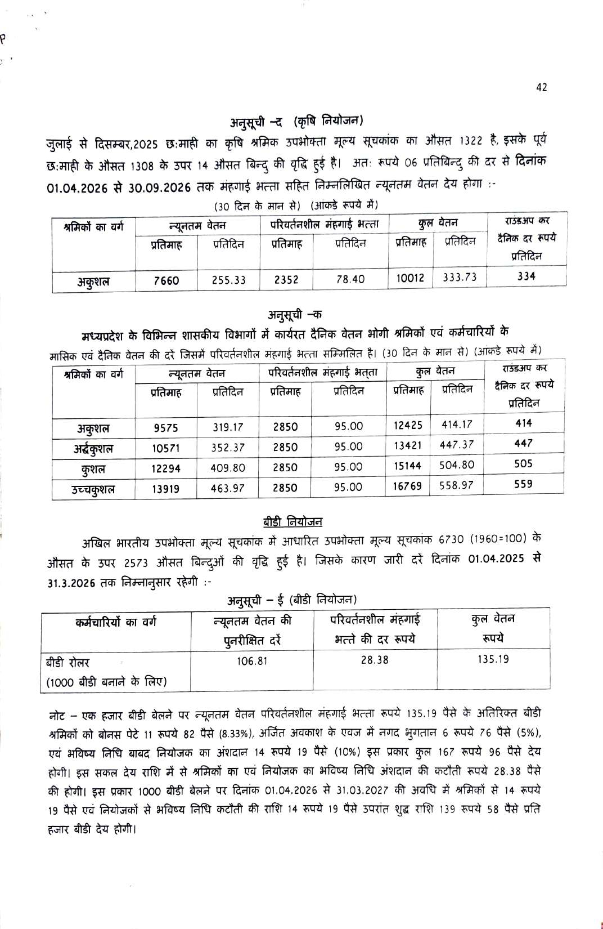
Cont’d to next page

“It always seems impossible until it’s done.” – Nelson Mandela

DEWAS UDYOG CIRCLE | 08 | March, 2026
NOTIFICATIONS/circulars
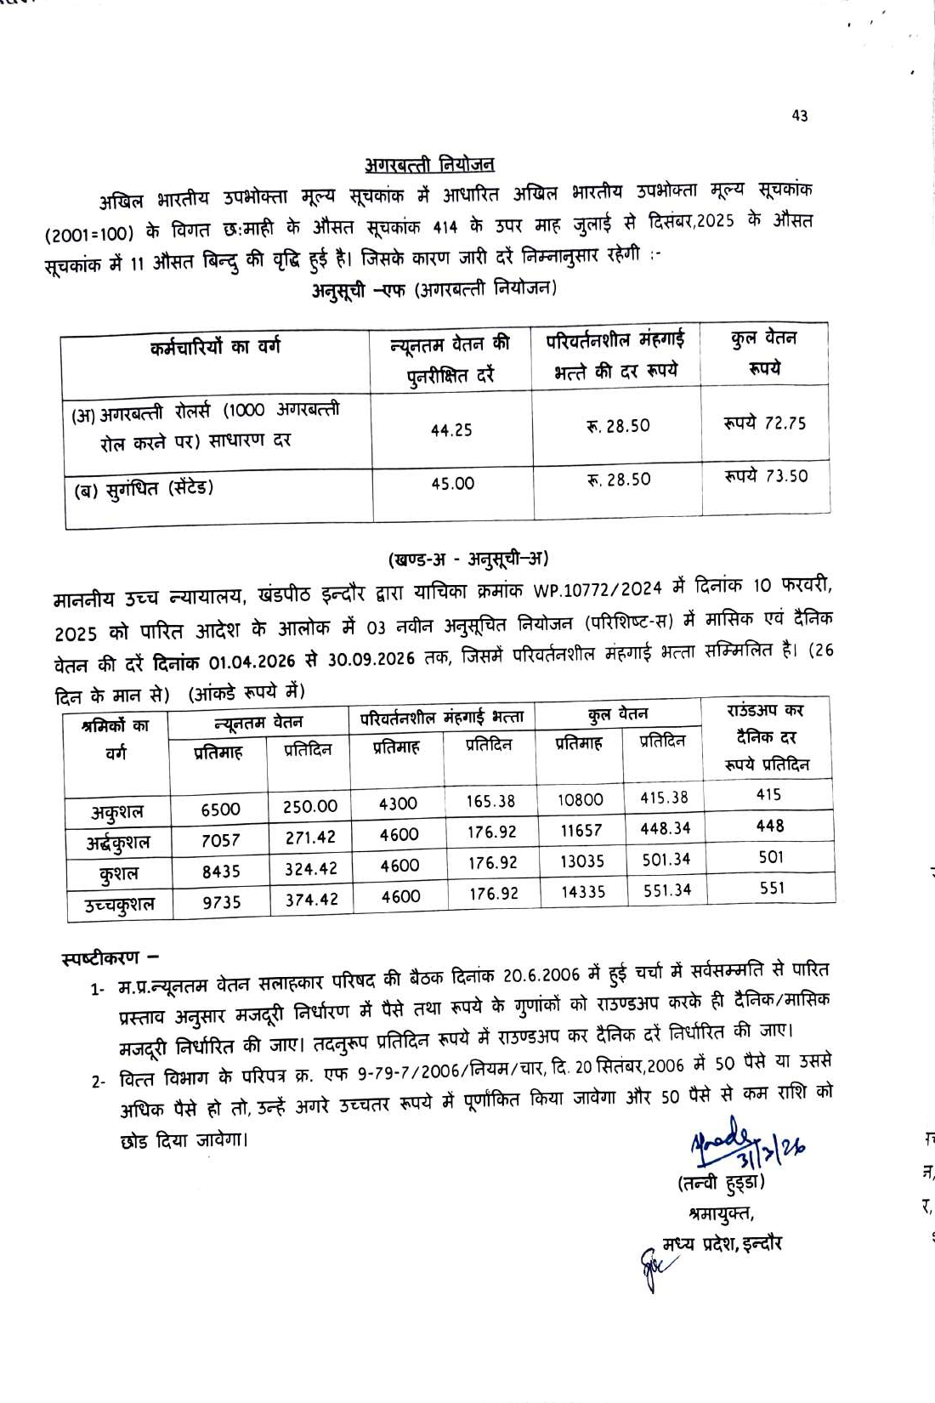

“We cannot solve problems with the kind of thinking we employed when we came up with them.” —Albert Einstein

 | 09  DEWAS UDYOG CIRCLE | March, 2026
NOTIFICA TIONS/circulars
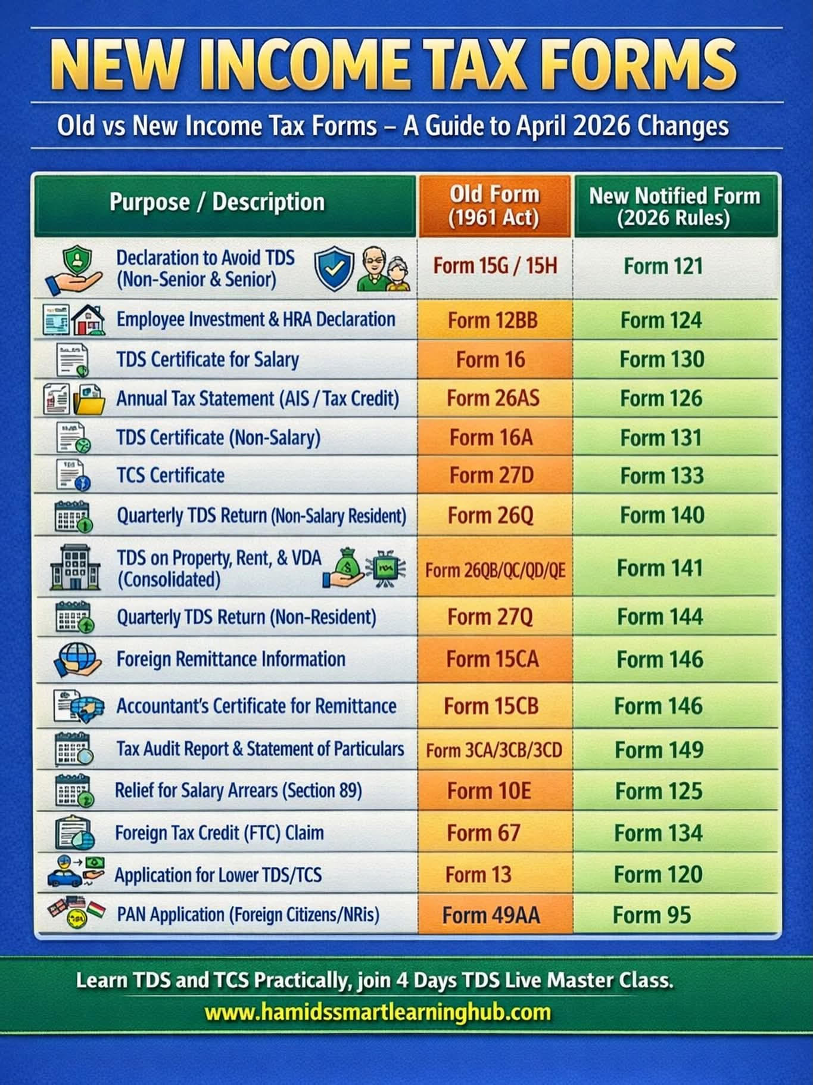

“The best way out is always through.” – Robert Frost

DEWAS UDYOG CIRCLE | 10 | March, 2026
NOTIFICA TIONS/circulars

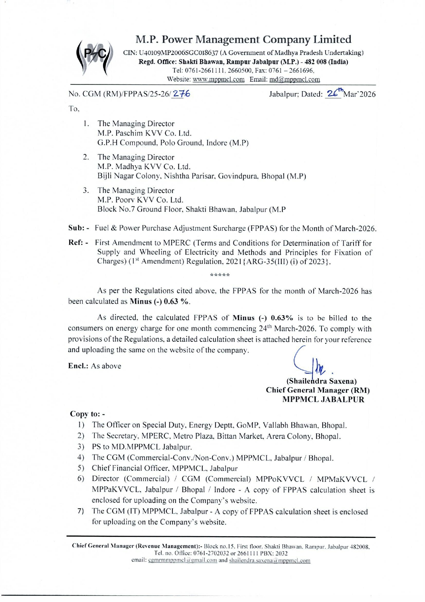
Cont’d to next page

“To know how muc there is to know is the beginning of learning to live.” —Dorothy West
“Concentrate all your thoughts upon the work in hand. The sun’s rays do not burn until brought to a focus.” —Alexander Graham Bell  DEWAS UDYOG CIRCLE | 11 | March, 2026
NOTIFICA TIONS/circulars
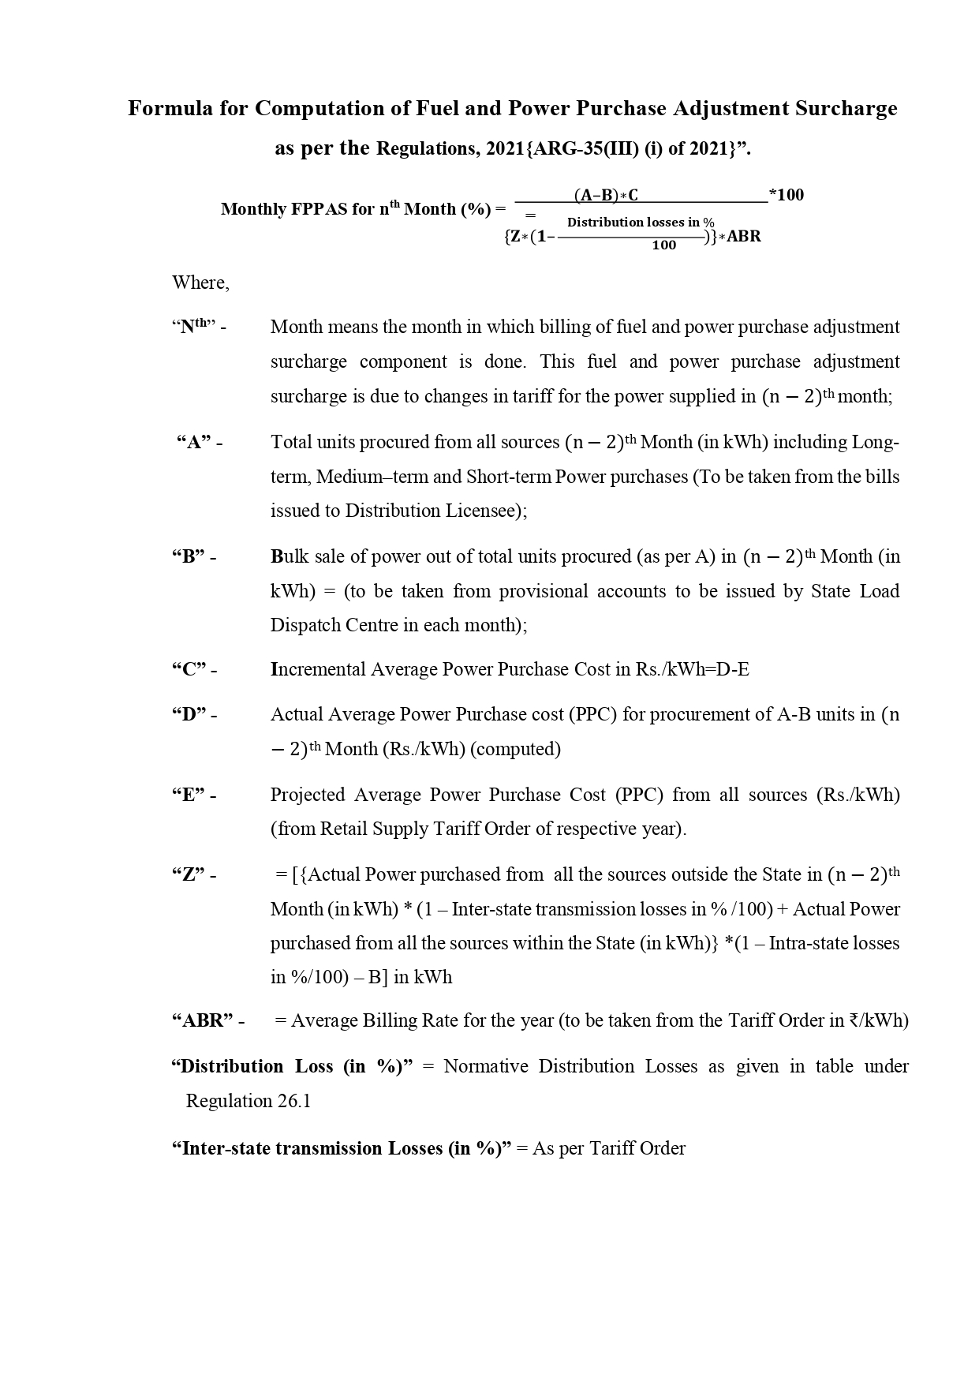
Cont’d to next page

DEWAS UDYOG CIRCLE | 12 | March, 2026
NOTIFICA TIONS/circulars

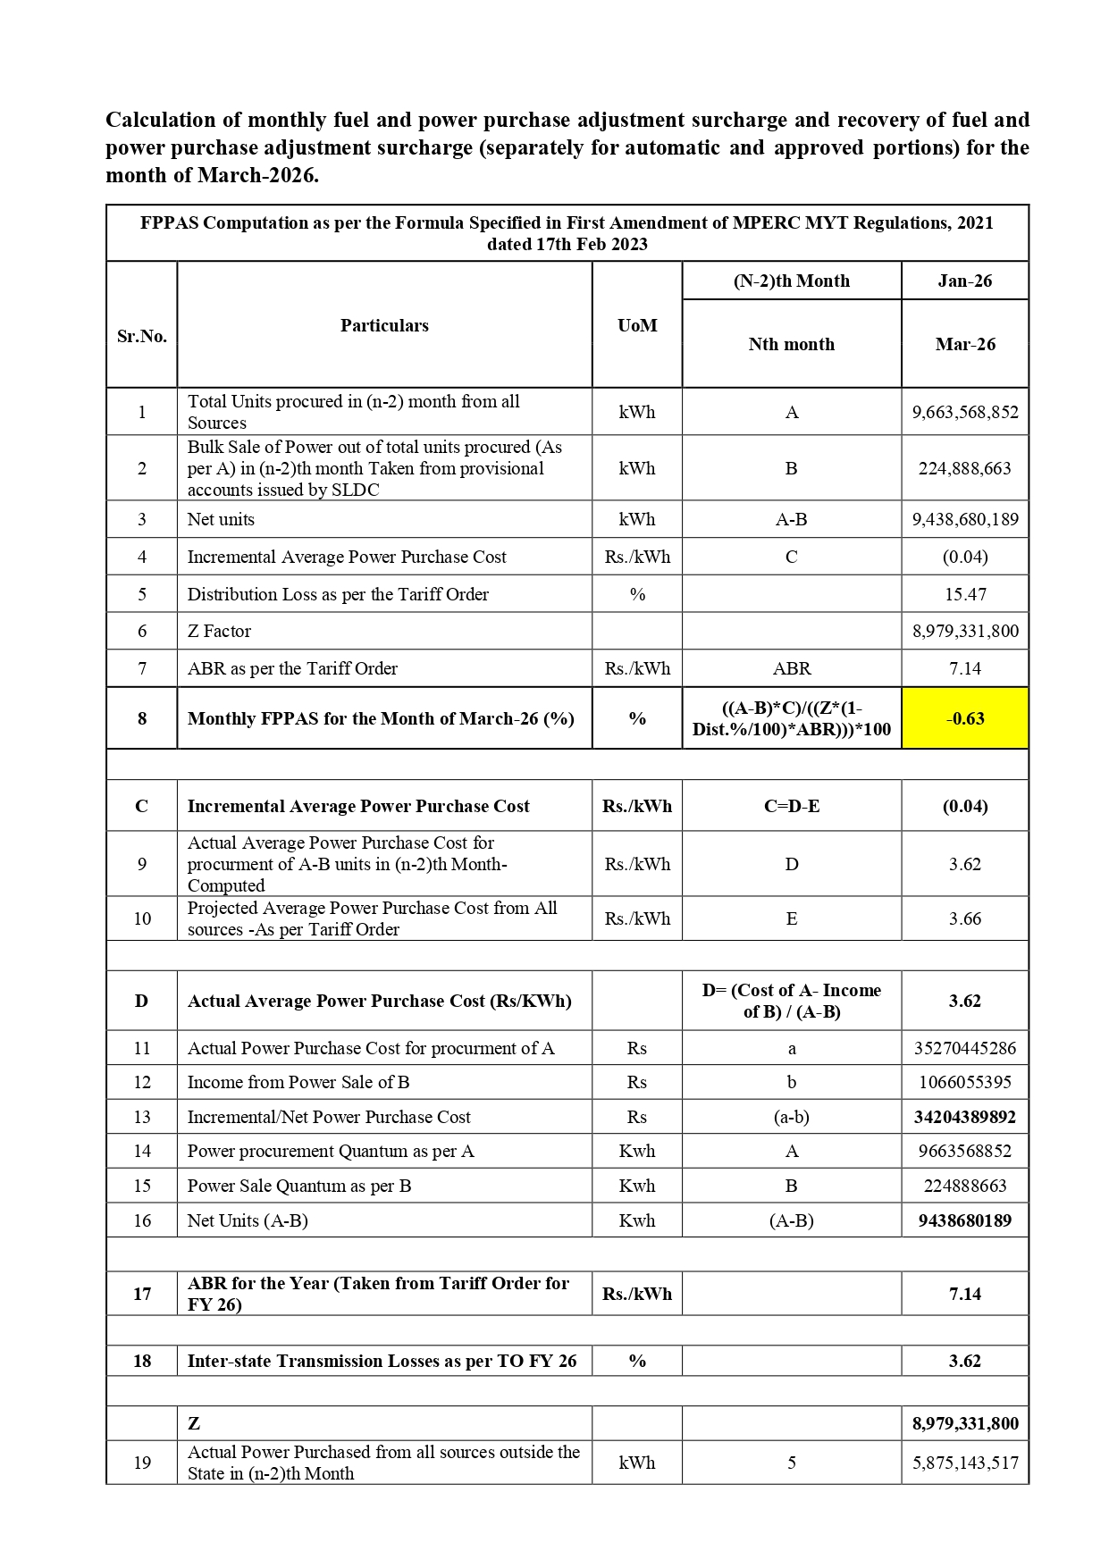

“To know how much there is to know is the beginning of learning to live.” —Dorothy West

DEWAS UDYOG CIRCLE | 13 | March, 2026
NOTIFICATIONS/circulars
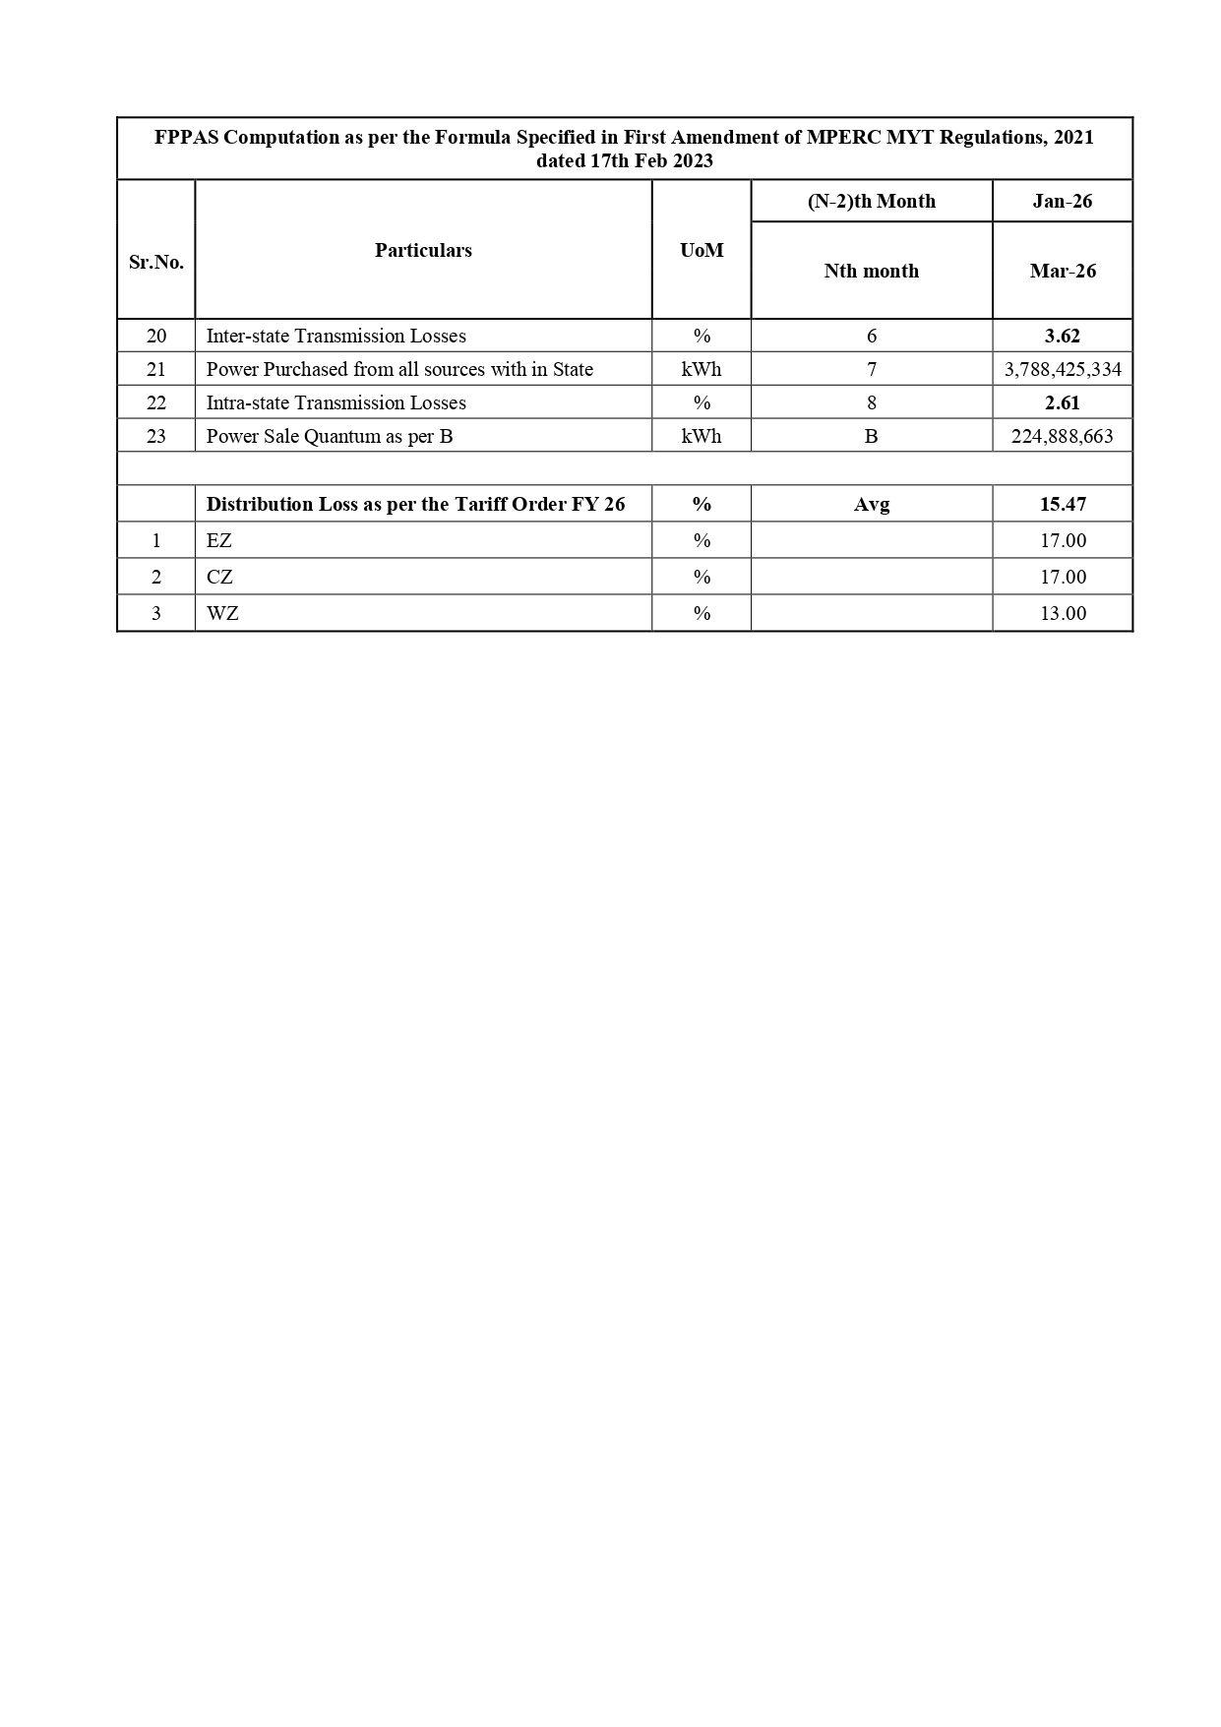

“The only way to have a friend is to be one.” – Ralph Waldo Emerson

DEWAS UDYOG CIRCLE | 14 | March, 2026
EventS

MEETING REGARDING GAS SUPPLY SITUATION FOR INDUSTRIES AT DEWAS

To fully understand and discuss the issues affecting gas supplies arising from the situation in the gulf Countries, a meeting of gas consuming Industries was organized at the office of the Association of Industries, Dewas on 16.03.2026 (Monday).
Senior officers from Gail Gas Ltd. were also present in the meeting.
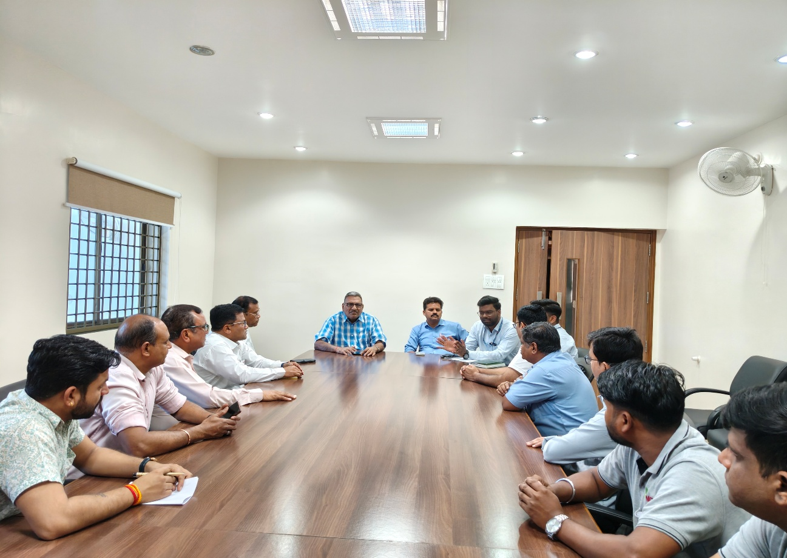
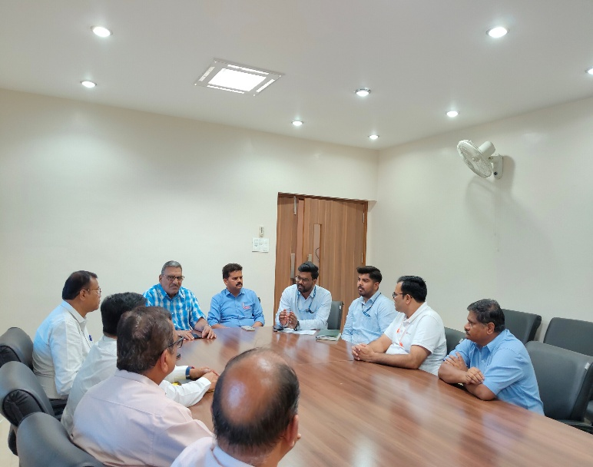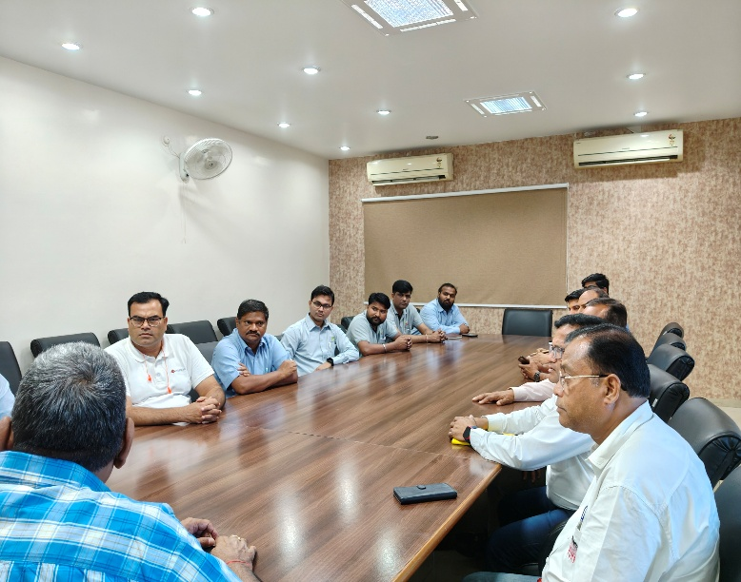

“The only way to have a friend is to be one.” – Ralph Waldo Emerson

DEWAS UDYOG CIRCLE |  | 15 |  | March, 2026
EventS

MEETING ON GUIDELINES FOR USAGE OF CNG/PNG/LPG

A meeting was scheduled by MPIDC in coordination with the Association of Industries Dewas at AID on 24.03.2026 to provide necessary guidelines and directions to industries regarding the usage and supply of commercial LPG/CNG/PNG and also to understand the difficulties faced by the Industries in the supply of Gas.
Shri Vinay Tomar GM, MPIDC Ujjain, Shri Rajneesh Goel GM, Gail Gas Limited and Shri B.S. Rai Assistant Supply Officer, Collectorate Dewas and other senior officers were present in the meeting.
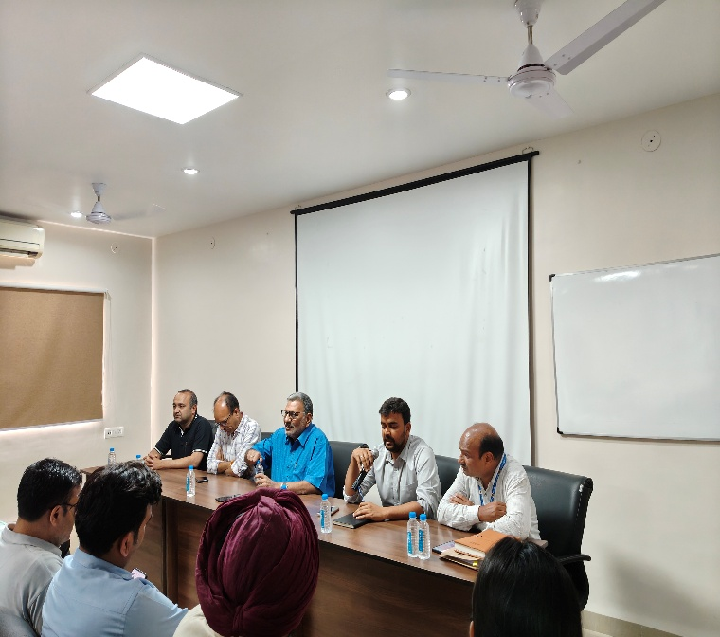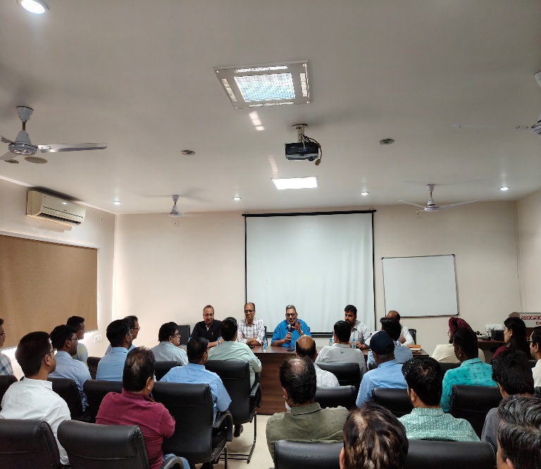
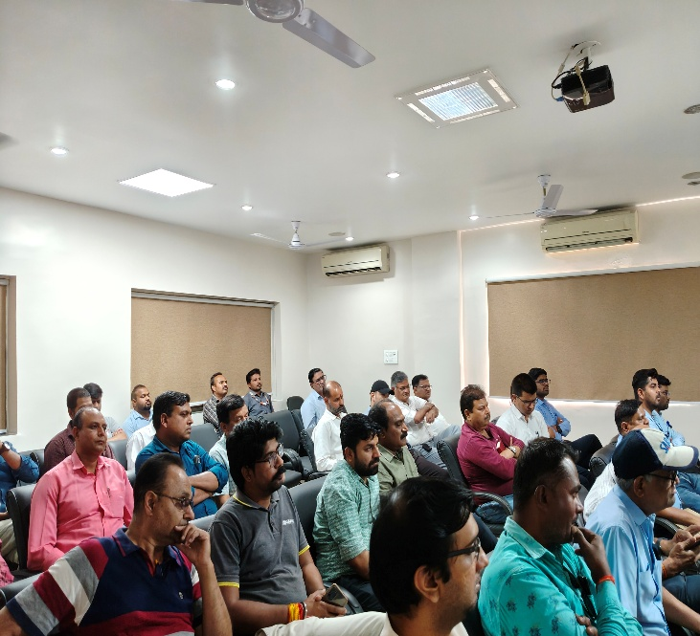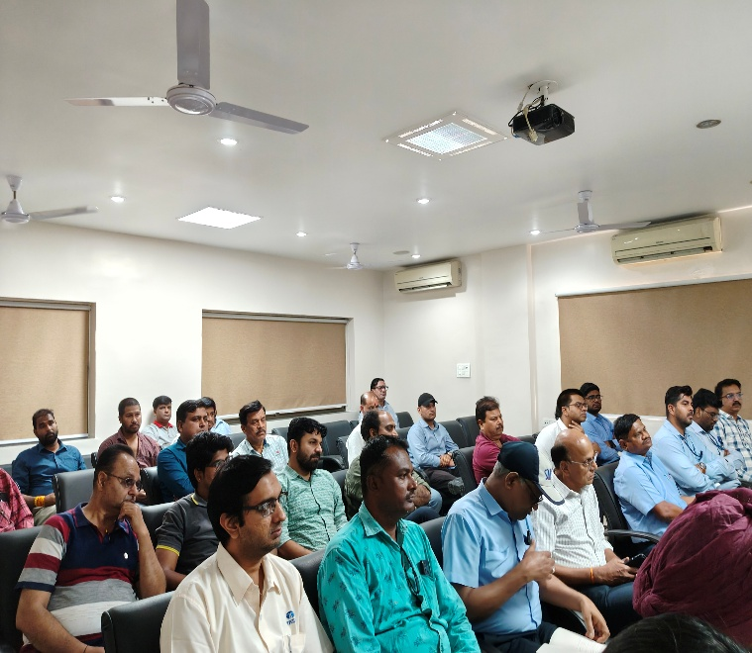

“Either you run the day or the day runs you.” —Jim Rohn

 | 16 |  | March, 2026
DEWAS UDYOG CIRCLE
With Best Compliments from



Published by Anjan Shah for & on behalf of the Association of Industries Dewas
1/B/1, 1/B/2A, Industrial Area No. 1, A. B. Road, Dewas—455 001 E-mail: aidewas123@gmail.com, mail@aidewas.org Website: www.aidewas.org

